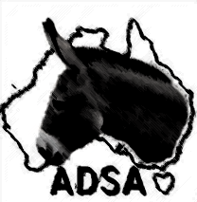
AFFILIATED DONKEY SOCIETIES OF AUSTRALIA.
PREFIX AND BRAND REGISTRATION

Name of owner/s: _________________________________________________________________________
Owners address: ________________________________________________________________
_________________________________________ Phone No: _______________________________
Email: ___________________________________ Web site: _______________________________
PREFIX: ______________________________________
Brand: _______________________________________
Fee: $5.00

Comments on Prefix: Registered names for animals on the ADSA registry can be no longer than 24 characters. This includes the Prefix name, all letters and spaces. The longer the Prefix the less flexibility you have for the animal’s registered name.
Comment on brands: It is not compulsory to have a brand. Many members have their animals’ micro chipped for permanent identification; this is acceptable to the ADSA. As registration certificates are computer generated the brand is described in text on the certificates. A brand that is easy to describe in text format is appreciated.

Signature of applicant: _______________________________________________________

Date: _____________________

Return form and fees to:
ADSA Registrar
5220 Orara Way Braunstone NSW 2460

