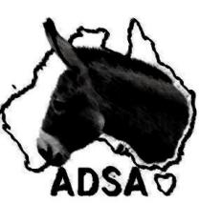
AFFILIATED DONKEY SOCIETIES OF AUSTRALIA.
VETERINARY EXAMINATION REPORT
Name of donkey__________________________________________________________________
Registration no: _____________________ Brands/microchip: _____________________________
Age: ________ Sex: __________ Colour: ______________________________ Height: _________
Name of owner: ___________________________________________________________________
Owners address: __________________________________________________________________

The above described animal is to be used for breeding and attention should be made to the following points by the inspecting veterinarian.
Genitals: in the case of males, both testicles should be descended and of normal appearance.
Bite: Overbite ……..mm Underbite ……mm
Legs and feet
Heart and lungs
Action at walk and trot
Free of any discernible hereditary defects.
Comments:___________________________________________________________________________________________________________________________________________________________________________________________________________________________________________________________________________________________________________________________________________
Signature of examining Veterinarian _______________________________________________________
Printed name of Veterinarian ____________________________________________________________
Date: _____________________
Return with registration form to:
ADSA Registrar
15220 Orara Way Braunstone NSW 2460

